Report
Of
Topic

Submitted
To
School of Computer Science and Engineering
IILM University, Greater Noida, U.P.

In partial fulfilment of the requirement of degree of
B.Tech CSE



By
Roll Number of Student: 2410031002
Name of Student: SURBHI SAGAR
Batch: 2026-27

CANDIDATE’S DECLARATION

I, SURBHI SAGAR do hereby declare that the internship report titled “DATA ENGINEERING VIRTUAL INTERNSHIP” has been completed by me to fulfil the requirement for the award of the degree of Bachelor of Technology in CSE. All the references have been quoted and I have not taken as such any material from any other source. I affirm to you that this report is my own and has not been submitted to any other institute for any degree/diploma requirement and further I shall be solely responsible for any kind of copyright violation in this regard.

Signature
Student Name: SURBHI SAGAR
Roll No.: 2410031002

ACKNOWLEDGEMENT

I am using this opportunity to express my gratitude to everyone who supported me throughout the Internship Program. I am thankful for their aspiring guidance, invaluably constructive criticism and friendly advice during this work. I am sincerely grateful to them for sharing their truthful and illuminating views on a number of issues related to this work.
I express my gratitude to my parents for their blessings.

Signature
Student Name: SURBHI SAGAR
Chapter No. | Chapter Name | Page Nos.
 | Cover Page | 1
1. | Candidate’s Declaration | 2
2. | Acknowledgment | 3
3. | Internship Completion Certificate | 4
4. | Project Description  4 .1 Introduction  4.2 Organization Profile  4.3 Problem Statement  4.4 Project Objectives  4.5 Scope of the Project  4.6 Technologies and Tools Used  4.7 System Architecture  4.8 Methodology  4.9 Expected Outcomes  4.10 Certificates of completion and other communication mail proof must be attached | 5-10
5. | Bibliography/References | 10
Roll No.: 2410031002

INTERNSHIP COMPLETION CERTIFICATE
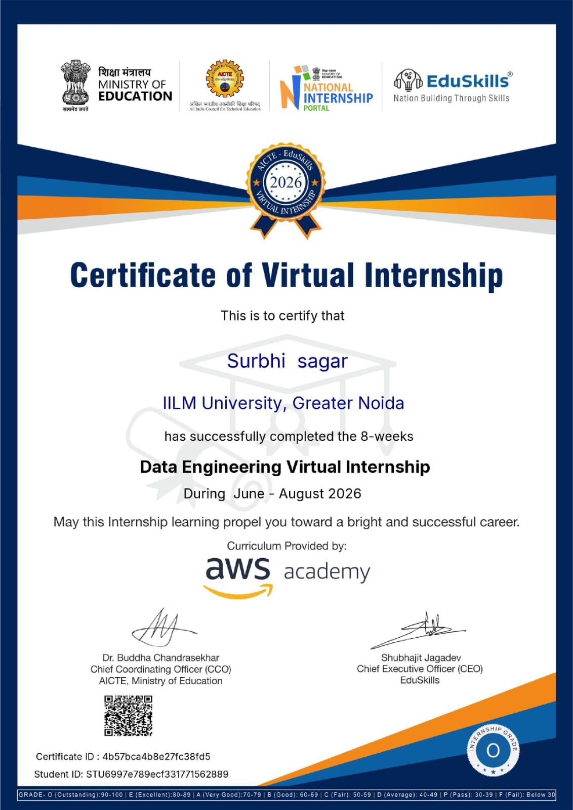

4. Project Description
4.1 Introduction
The Data Engineering Virtual Internship was an 8-week AICTE–EduSkills Virtual Internship Program in the domain of AWS Data Engineering. The internship was held from June 2026 to August 2026. As mentioned in the letter of internship, the program was planned to include structured learning along with practical experience and contained weekly evaluations, assignments, and finally a test at the end of the program.

4.2 Organization Profile
This internship opportunity was provided by EduSkills under AICTE-EduSkills Virtual Internship Programme. The documents provided mention EduSkills as the internship providing company, along with the AWS Academy curriculum. This certificate also bears the logo of Ministry of Education, AICTE, National Internship Portal and EduSkills. This internship was based on industry-relevant data engineering and cloud-based data technologies.

4.3 Problem Statement
Data-driven companies require effective techniques for collection, storage, processing, security, analysis, and visualization of data. This is why the internship was designed to fulfill the learning objectives through data engineering and AWS services used for data pipelines, analytics, big-data processing, and visualization.

4.4 OBJECTIVES OF THE PROJECT
Objectives of the internship included the following:
- Learning the basics of data engineering and data-driven companies.
- Understanding the role of data engineers in modern companies.
- Learning the basics of data pipelines and pipeline architecture.
- Learning about data quality and five Vs of data.
- Learning about data ingestion and ETL & ELT process.
- Learning about data cleaning, data enrichment, validation and data publishing.

4.5 SCOPE OF THE PROJECT
The scope of the Data Engineering Virtual Internship included all the key stages of data engineering in today’s cloud environment.
These key stages include data storage, data ingestion, data processing, ETL and ELT, data cleaning, data validation, data enrichment, data analysis and visualization.
It also included all the concepts associated with batch and stream processing, big data, and machine learning data preparation.

4.6 TECHNOLOGIES & TOOLS USED
Some of the key technologies and AWS services that were taught during the internship include:
1. Amazon S3
S3 is an AWS service for cloud-based data storage. It was part of the Week 1 practical lessons.
2. Amazon Athena
Athena is used to query data. It was part of the curriculum and was also used in ETL pipelines labs.
3. AWS Glue
Glue was taught for ETL related data processing.
4. Amazon Kinesis
Kinesis was taught for data ingestion and stream-processing related operations.
5. Amazon Redshift
Redshift was used for data management and big-data related lessons.
6. Hadoop
It is a big data technology. It was introduced during the internship.
7. Apache Spark
Spark was taught for big data processing.
8. Amazon EMR
EMR was part of big data lesson.

4.7 SYSTEM ARCHITECTURE

System architecture is defined by the flow of information in various stages within the process of data engineering. Information is initially acquired from diverse sources and ingested by appropriate means. The information is then stored in Amazon S3. Once stored, the information is processed and transformed through ETL tools such as AWS Glue. Once the information is processed, it is then queried and analyzed using Amazon Athena and Amazon Redshift.

4.8 METHODOLOGY
The internship was conducted under a week-wise structured learning methodology. The process of learning comprised of theoretical concepts, practical exposure, hands-on training, weekly evaluation, project documentation and a final evaluation.
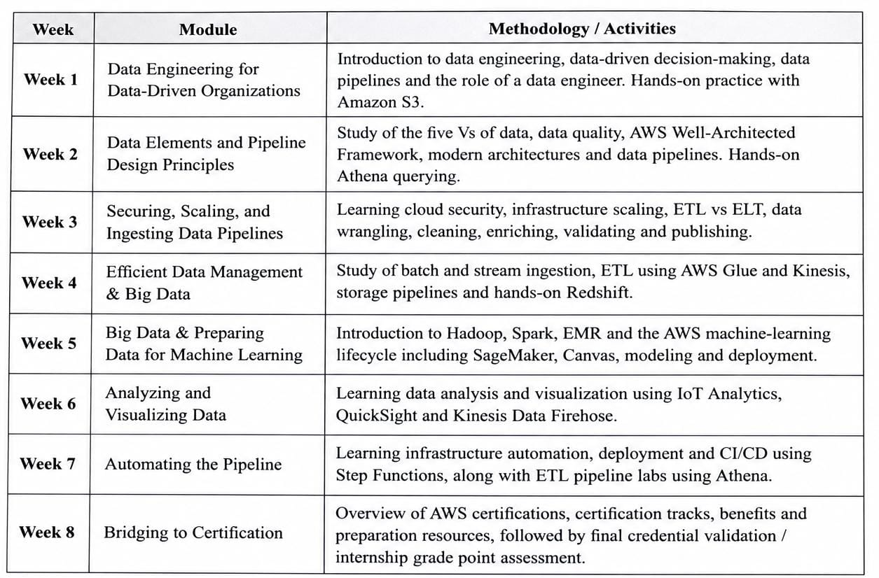

4.9 EXPECTED OUTCOMES
The following were some of the expected learning outcomes from the internship:
- Knowledge of basic concepts of data engineering.
- Knowledge of contemporary data pipelines and architectures.
- Knowledge of cloud-based data storage and processing.
- Knowledge of ETL and ELT processes.
- Knowledge of data cleaning, enrichment and validation.
- Knowledge of batch and stream data ingestion.
- Awareness of some AWS data engineering services.
- Basic knowledge of big-data technology such as Hadoop, Spark and EMR.

4.10 CERTIFICATES OF COMPLETION AND OTHER COMMUNICATION MAIL PROOF
The internship offer letter confirms that Surbhi Sagar, B.Tech in Computer Science and Engineering from IILM University, Greater Noida, was selected for the 8-week AICTE–EduSkills Virtual Internship Program in the AWS Data Engineering domain for the duration June 2026 – August 2026.
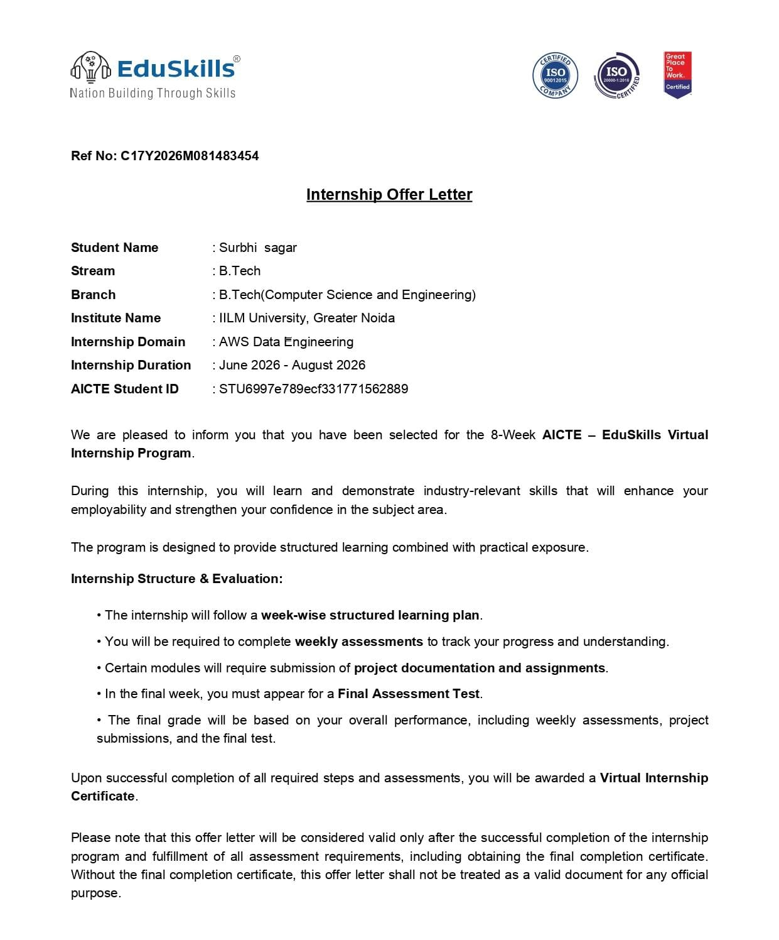
Furthermore, AWS Academy Graduate – Data Engineering – Training Badge has been awarded to me. This badge is an indication of 40 hours of Data Engineering training which has been completed by me on 24th July 2026.
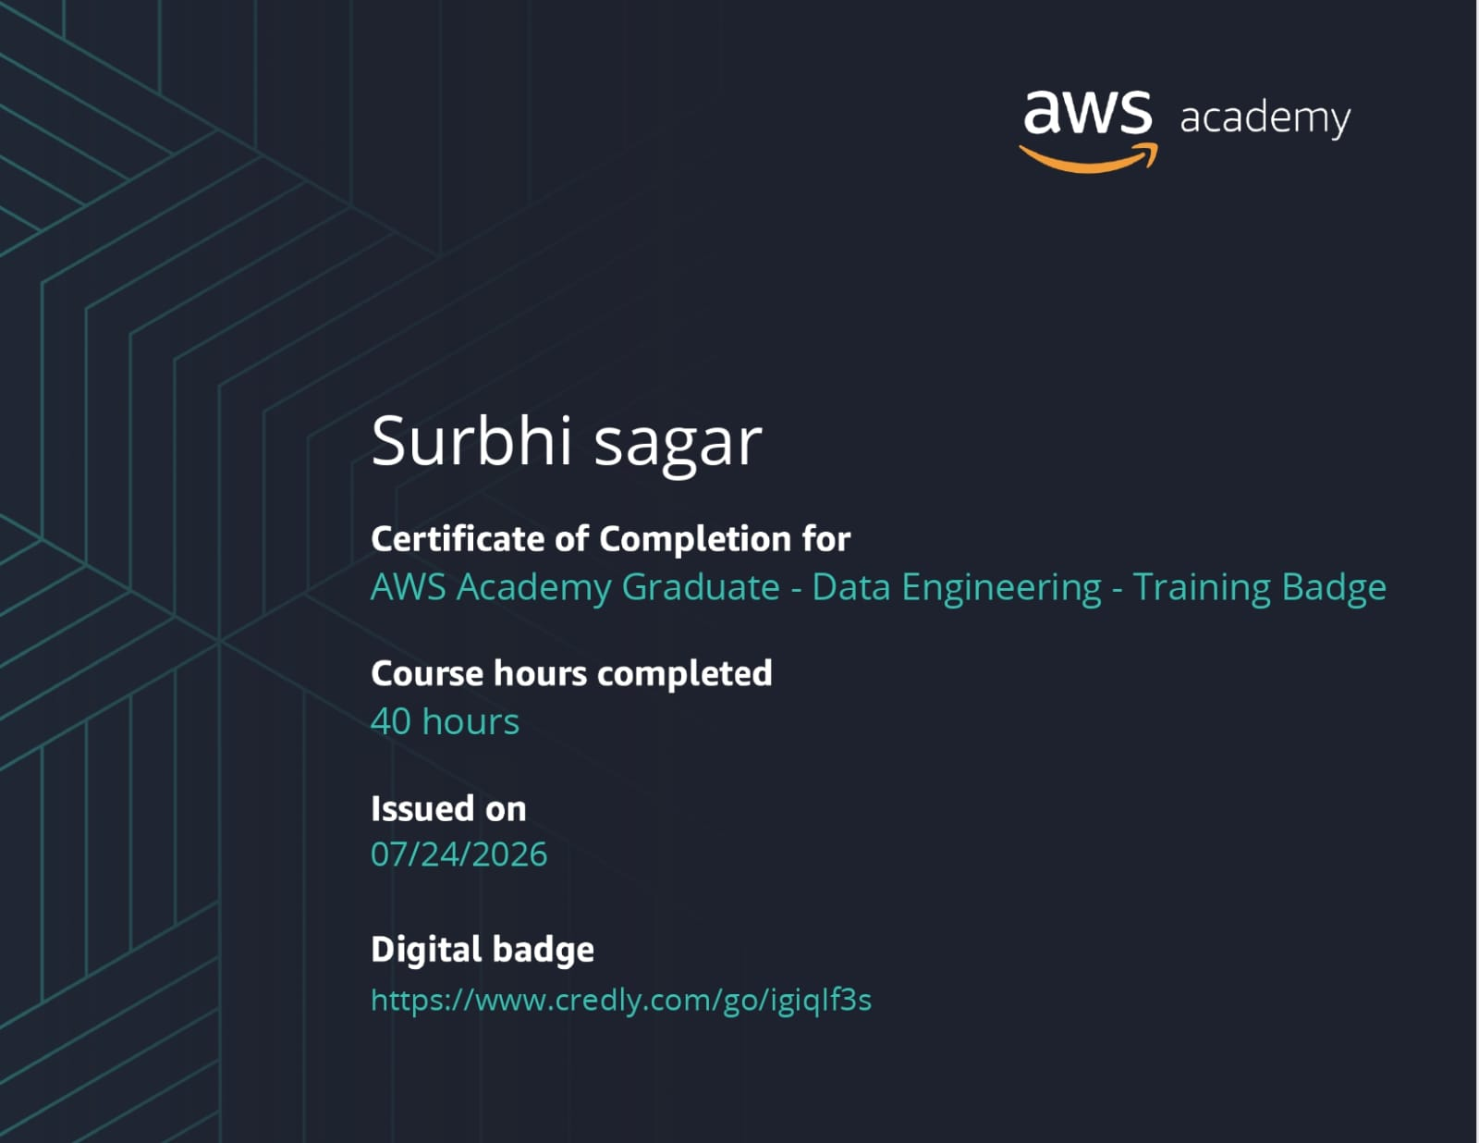

BIBLIOGRAPHY / REFERENCES
[1] EduSkills, Internship Offer Letter, Ref. No. C17Y2026M081483454, AICTE–EduSkills Virtual Internship Program, AWS Data Engineering, June–August 2026.
[2] AICTE–EduSkills, Certificate of Virtual Internship, Data Engineering Virtual Internship, June–August 2026. Curriculum provided by AWS Academy.
[3] AWS Academy, AWS Academy Graduate – Data Engineering – Training Badge, 40 hours of training, issued on 24 July 2026.
[4] IILM University, School of Computer Science and Engineering, Internship Report Format Updated 26–27, Batch 2026–27.

